**DAILY ONLINE ACTIVITIES SUMMARY**

|  |  |  |  |  |  |  |  |  |
| --- | --- | --- | --- | --- | --- | --- | --- | --- |
| **Date:** | **14/06/2020** | | | | | **Name:** | **Katira Krishna J** | |
| **Sem & Sec** | **8th A** | | | | | **USN:** | **4AL16CS045** | |
| **Online Test Summary** | | | | | | | | |
| **Subject** | | **-** | | | | | | |
| **Max. Marks** | | **-** | | **Score** | | | **-** | |
| **Certification Course Summary** | | | | | | | | |
| **Course** | **Data Visualization using python** | | | | | | | |
| **Certificate Provider** | | | **Cognitiveclass.ai** | | **Duration** | | | **10 hours** |
| **Coding Challenges** | | | | | | | | |
| **Problem Statement: Python program to print Fibonacci series without using recursion** | | | | | | | | |
| **Status: Completed** | | | | | | | | |
| **Uploaded the report in Github** | | | | | **Yes** | | | |
| **If yes Repository name** | | | | | **Krishna_Katira** | | | |
| **Uploaded the report in slack** | | | | | **Yes** | | | |

Online Test Details:

No Test Conducted

Certification Course Details:

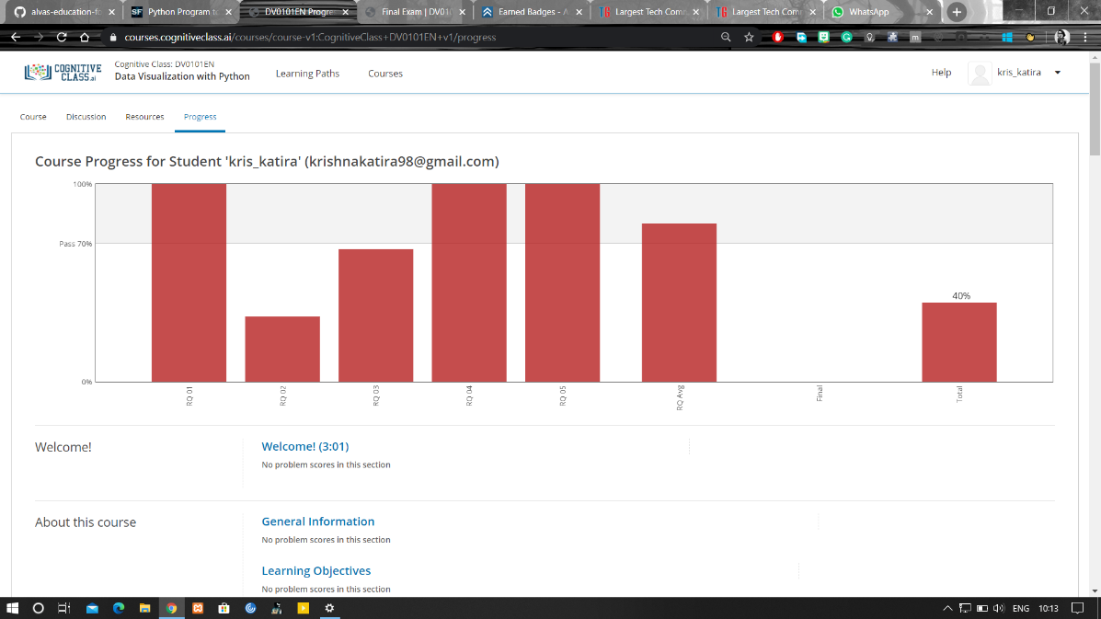

Coding Challenges Details:

**Program:**

a=int(input("Enter the first number of the series "))

b=int(input("Enter the second number of the series "))

n=int(input("Enter the number of terms needed "))

print(a,b,end=" ")

while(n-2):

c=a+b

a=b

b=c

print(c,end=" ")

n=n-1